Pacific humpback whale behavioral changes throughout the winter season in leeward O‘ahu

Melanie R. Stevens
College of Natural Science, Hawai’i Pacific University
MARS 4910
Dr. Chelsie Counsell
April 30, 2023

Abstract
Humpback whales are seasonal migratory breeders that express changes in behavior and social structure throughout their mating season. Pacific humpback whales migrate to the waters of Hawai’i between the winter months of December through March. While in their mating grounds, there is a higher male to female ratio resulting in competition between males for mating rights to females. This results in a change of social structure between humpback whales. While significant studies have been conducted for whale behavior and social structure in Maui, Australia, and other regions of the world, there has been little to no research on humpback whale behavior changes in leeward O‘ahu. In this study, observational surveys were conducted between the months of January to the beginning of April aboard the R/V Alaka‘i in leeward O‘ahu. Pod composition and behaviors expressed (fin slapping, breaching, and singing) were recorded to determine any variation in the frequencies of behavioral events expressed across pod types. Behavioral data was analyzed using a chi-square analysis, and trends in behavior and pod sizes were graphed through the duration of the season. Results showed that given the number of times a behavior was observed, there is significant variation in the frequency of behavior expression from different pod types (p=0.00086). Given that a pod type expresses behaviors, the data shows they are equally likely to express each behavior (p=0.052). There was a common trend in the number of whales observed per pod, frequency of behaviors expressed, and number of whales observed per survey, each with a peak around mid-March, and a rapid increase until the end of the season.

Introduction
Seasonal breeders are animals that breed successfully during specific times of the year when breeding is most advantageous for offspring survival (Brower & Malcolm 1991; Prendergast 2005). These times of the year yield the highest survival rate for young due to optimal temperature, food availability, or changes in predation behaviors of other species (Prendergast 2005). While in mating season, species may experience both physical and behavioral changes. These changes occur across different time frames, including annual, biannual, or even more frequently (Prendergast 2005). During these seasonal breeding periods, females will enter the fertile period of their sexual cycle, and often become more receptive to mating advances, described as estrus (Prendergast 2005). Males may exhibit changes in testosterone levels, testes weight, and fertility. Mating seasons are also commonly associated with changes to population social structure, as well as behavioral changes (Prendergast 2005).
Many species of rodents, ungulates, and marine mammals that participate in seasonal mating migrate for optimal environmental factors in favor of breeding and offspring survival success (Prendergast 2005). Species migration occurs as a legacy from the Pleistocene era to escape predation, avoid winter cold, reduce competition, take advantage of resource availability, or to leave excessive dry or wet season areas (Brower & Malcolm 1991). Species that are migratory seasonal breeders often feed in one area and have separate breeding grounds. Migration to an area advantageous for mating and breeding creates a more distinct change in social and competitive behaviors. This change in behavior can evolve throughout a mating season to create a trend in observed social relationships.
Humpback whales (Megaptera novaeangliae) are a species that participate in large-scale migrations for mating and breeding purposes (Cartwright & Sullivan 2009, Herman et al. 2011). Humpback whales are present in all oceans around the world, in different populations separated geographically. Each population resides in cold waters near the poles during summer months for feeding, then travels to warm waters near the equator in the winter months for mating and breeding (Barlow et al. 2011). Large scale photo-identification programs as well as aerial and ship-based line-transect methods have been implemented to track humpback population and migration patterns since the 1900s (Cerchio et al. 1998, Barlow et al. 2011, Herman et al. 2011). The North Pacific population of humpback whales resides primarily along the Pacific Rim of California, USA to Kamchatka, Russia for feeding, and migrates to Hawai‘i, Mexico, and the coasts of Central America during the winter season for mating and breeding (Barlow et al. 2011). They migrate to avoid predation from orcas (Orcinus orca) and for warmer waters safe for calving. In high latitude feeding areas, humpback whale social organization is described as fission-fusion society, in which all individuals are never together in one group. There is low level of cohesion and a lack of dominance within social structures in feeding areas (Corkeron & Brown 1995). In winter breeding grounds, however, humpback whales display competitive behavior and have clear dominance within pods (Corkeron & Brown 1995, Cartwright & Sullivan 2009).
Different categories (i.e. males, females, females with calves, etc) of humpback whales migrate at slightly different times, which can alter whale mating and social structure on breeding grounds (Avila et al. 2020). In Hawai‘i (as well as most other breeding areas) the sex ratio of humpback whales favors males (Craig et al. 2002, Cartwright & Sullivan 2009, Herman et al. 2011). This results in competitive behavior between males for access to mating rights with available females. Female attractiveness is based on reproductive potential, meaning females without calves will be more attractive to males (Craig et al. 2002, Herman et al. 2011). Pregnant female humpback whales may remain on feeding grounds for up to two months longer than male and non-pregnant female whales to feed longer and account for the additional energy costs of pregnancy and lactation (Kettemer et al. 2022). This means that earlier in the season, female whales without calves are likely to be more prevalent. Because they are the most attractive to male whales for breeding, they will most likely be guarded by males first before females with calves. Therefore, pods of two may be more likely seen than pods of three in early to mid season. As the season progresses, lone female whales will have already been guarded (Corkeron & Brown 1995), thus females with calves become more attractive, and pods of three or more (with more frequent heat runs) will be seen (Franklin et al. 2011).
Identifying whale pod composition is key to determining whale mating behavior. Because whale mating and social structure is focused on male-male competition rather than sperm competition (Corkeron & Brown 1995), the number and categories of whales in a pod give insight to the mating and social strategies occurring in the pod. For example, a pod of two adult whales can be assumed as a female and a male that is ‘mate guarding.’ A pod of one adult male and one calf can be assumed to be a mother and calf. A pod of three whales that includes one calf is likely a mother, calf, and escort (a whale that guards the female and calf, usually a male whale). A pod with more than two adults can be assumed to be competition between male escorts around a single female whale (Corkeron & Brown 1995). There have been multiple studies on average pod size and composition changes throughout the winter mating season in both Australia and Maui, Hawai‘i (Corkeron & Brown 1995; Cerchio et al. 1998; Franklin et al. 2011; Herman et al. 2011); however to my knowledge, studies are limited on the west coast of O‘ahu.
In this study, I will use opportunistic observational data gathered by sight and photography on the leeward Coast of O‘ahu on R/V Alaka‘i throughout the winter season (January through March) to survey pod composition and their associated behaviors. The number of adults and calves will be recorded for each pod, and any behavior portrayed such as singing, fin slapping, or breaching will be recorded. I will compile and analyze this data to determine if there are any compositional or behavioral trends within the pods as the season progresses. This research will address the following hypotheses: 1. Throughout the winter season, average humpback whale pod composition will change as mating behaviors change. 2. As mating season progresses, the male whales will display more competitive behavior for remaining unpaired females, until there are no longer available females. I predict there will be more competitive pods consisting of a female and multiple competing escorts later in the season. Frequency of breaching, fin slapping, and singing, will increase mid-season (during peak mating season) and decrease as more whales are paired off and there are less remaining available females.

Methods
Environmental Setting
The area of study is located on leeward (west) side of Oahu, from Naval Air Station (NAS) Barber’s Point to Ka‘ena point, within four miles of shore (Fig. 1). We leave from Wai‘anae Harbor and go either north or south depending on weather conditions and wildlife reports from other boats. This study was performed between the months of January 2023 to April of 2023. During this time of year, strong winds average between 6 to 7 meters per second, with some exceptionally strong winds during storms or high northeast trade winds (WRCC). Temperature ranges between 15°C to 27°C during the winter season, with consistent cloud cover. Water temperature remains around 24°F to 27°F until beginning of spring season in April (WRCC). Swell on the west coast remains on an average of 1-1.5 meters during the winter months of January-February (WRCC).

Figure 1. Map of Study Site with longitude and latitude. The white box represents the study area from NAS Barber’s Point to Ka‘ena Point, with Wai‘anae Harbor (launch point) marked in red. This map was made using Google Maps satellite imagery.

Data Collection
In this study, opportunistic observational data was recorded on board R/V Alaka’i, a tour vessel under Wild Side Specialty tours. Data was recorded on board tours which was also sent to Happywhales.com and Cascadia research collective for participation in citizen science. Three hour surveys were conducted between January 13th to April 1st of 2023. One to three surveys were done on 17 data collection days, (Table 1). Each survey was done at 7:00 am, 11:00 am, or 3:00 pm. Throughout the 3-hour surveys, my team would look for whale pods and record behaviors expressed.

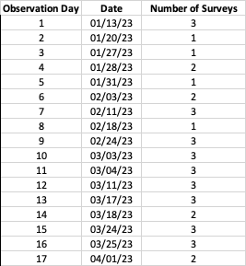
Table 1. Observation days 1-17 and the date of each day. Each survey conducted was 3 hours long.

Whales were found by watching for spouts. Observation time for each pod was dependent on whether other whales are observed in the area; how well we were able to observe said pods was based on down time, speed of movement, and visibility of water and weather conditions. The goal was to find as many pods as possible; however, if there were no reports of other whales, we may observe a pod of whales longer. Usually, we observed long enough to determine if there are abnormal behaviors, or any mating behaviors expressed.
To understand behavioral changes, visible behaviors such as fin-slapping and breaching, as well as pod composition were recorded. Data sheets were used to collect information for each pod observed. For each pod, the number of adults was recorded as well as the presence of a calf to determine pod composition. Photo confirmation (fig. 2) was used to increase confidence in data collected. Photos were taken using a Canon DSLR 70-300 mm zoom lens and a Canon DSLR 100-400 mm zoom lens (Supplemental materials: equipment list). Location of pod at first observation was recorded in GPS (longitude and latitude) coordinates using the Garmin on the captain’s helm. Behaviors portrayed were recorded, including singing, breaching, or fin and tail slapping. Singing was confirmed using a hydrophone. The hydrophone was dropped into the water directly next to the vessel with the speaker still on board. The hydrophone is dropped to 4 meters depth. If whale singing is heard nearby, occurrence is recorded. Number of breaches seen was recorded, as well as which individual from the pod breaching was recorded (if obvious). Breaching was recorded as a frequency, and number of breaches per individual pod or individual were recorded, as well as a binary occurrence, whereas fin-slapping and singing were recorded as a binary (yes/no) for occurrence of behavior. This is because it is difficult to determine the start and stop of fin-slapping and singing, so a tally would be inaccurate. All observations were within 300 meters proximity to the pod. Any pod outside of visible range was not included in the data. Observation time spent observing the whales was recorded, estimated by time of first sighting until the point of no more visibility. All observed pod composition and surface active behaviors recorded were confirmed in agreement with other team members including the captain and photographer.
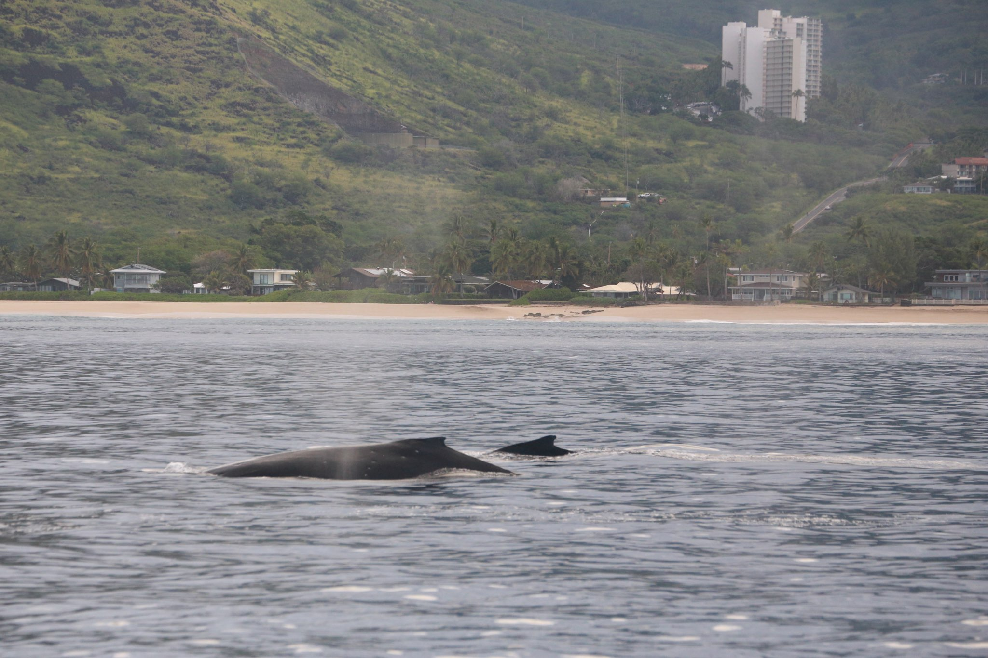
Figure 2. Example of photo confirmation of a mother and calf taken aboard R/V Alaka’i on February 3rd, 2023 using Canon DSLR 70-300 mm zoom lens. Photo is property of Wild Side Specialty Tours.

Data Analysis
The pods observed were categorized into pod types including singleton pods; mother and calf pods; adult pair pods; mother, calf, and escort pods; competitive group pods (pods with more than 2 adult whales); and competitive groups with a calf present. For behavioral expression, occurrence of breaching, fin slapping, and singing was used. For breaching, both the number of breaches expressed by one pod, and the occurrence of breaching (the number of pods that displayed breaching) were used in different statistical analyses.
To look at trends in behavior expression by pod type, a chi-square test was used to determine variability in behavior expression among pod types given the occurrence in which that behavior was observed. This first chi-square test compared the observed frequency of behavior event occurrence (breaching, fin-slapping, and singing) per pod type to the expected frequency in which pod composition does not impact the frequency of behavior expression. The second chi-square test was used to determine the variability in likelihood that a pod type would express a given behavior. The chi-square test compared the observed frequency in which a pod type expresses a behavior to the expected frequency in which each pod type is equally likely to express each given behavior. For both chi-square tests, the occurrence of expressed behavior events were used, in which the data was calculated by the number of pods that expressed the behavior, not the frequency of expressed behavior.
To determine any trends in number of whales observed, number of whales per pod observed, and number of behavioral events observed, scatter plots were made to show correlating trends of each variable. The frequency of breaching (number of breaches expressed across all pods observed) was plotted per survey over each day of the season, as well as fin-slap occurrence per survey, number of whales per survey, and number of whales per pod over the 17 observation days.

Results
In total, 205 individual whales were observed within 88 different pods. Of those 88 pods, 22 were singletons; 22 were adult pairs; 19 were mother and calf pods; 13 were mother, calf, and escort pods; 8 were competitive groups (pods with more than 2 adults), and 4 were competitive groups with a calf present.
The null hypothesis for comparison used in the first Chi-Square test is that given the number of times a behavior was observed, the behavior is equally expressed by different pod types. The chi square test statistic for this test was x² =29.971, with a chi-square critical value of 18.307 (α=0.05, DF=10) which indicates that the null hypothesis can be rejected. The p-value for the Chi-Square was p=0.000866182 which indicates significance in observed behavior frequency variation from the null hypothesis, indicating that behaviors are not equally expressed by different pod types. The variation of frequency from the null hypothesis for each pod (Fig. 3) indicates that adult pair pods show the highest frequency for breaching, followed by mother and calf pods. Competitive groups show the highest frequency for fin slaps, followed by competitive group pods with a calf present. Singleton pods show the highest frequency for singing, followed by adult pair pods (Fig. 3).

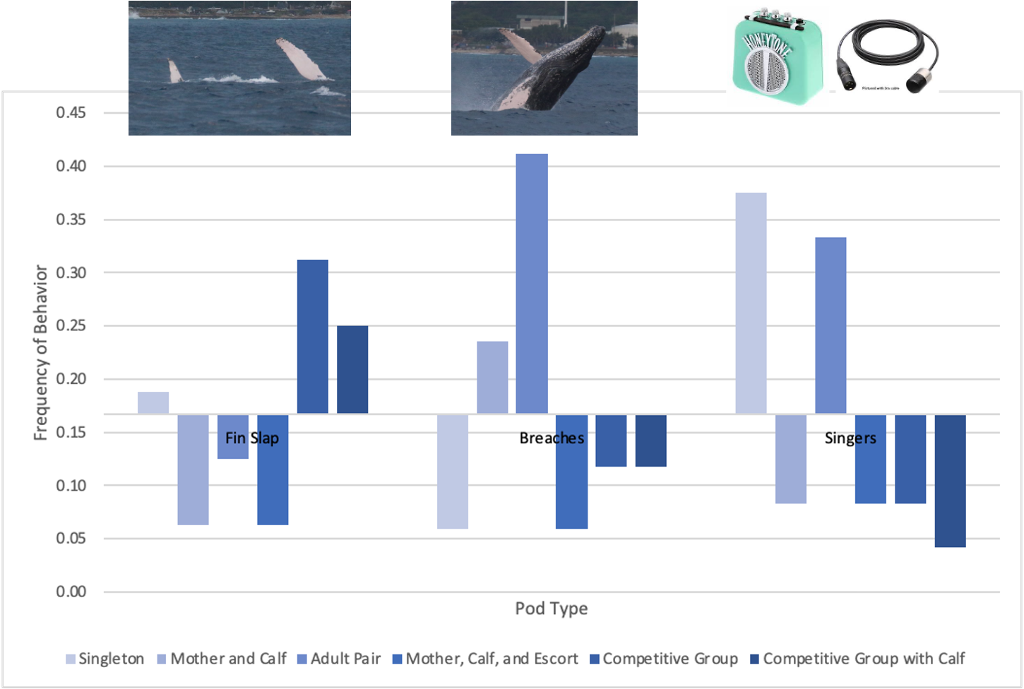
Figure 3 is a visual representation of the difference in frequency of expressed behaviors: singing, breaching, or fin slaps, from the null hypothesis for each pod type. Pod types include singleton, mother and calf, adult pair, mother, calf, and escort, competitive group, and competitive group with a calf. If the frequency of behavior expressed is equal across all pod types, then the frequency (f) of each behavior f=0.16. This was used as the baseline, and the observed frequency of behavior for each pod type was graphed in comparison to the null. Actual frequency of behaviors expressed is shown in supplemental materials, Table 1.

While adult pair pod were more likely to display breaching, mother and calf pods breached 4/17 times the behavior was observed. When mother and calf pods breached, they often breached multiple time consecutively. Mom and calf pods breached on average 8.75 times consecutively with a range of 1 to 30 times. Adult pair pods displayed breaching 7/17 times observed, and breached on average 2.4 times consecutively with a range of 1 to 3 times.
The null hypothesis used for comparison in the second Chi-Square test is: given that a pod type expresses behaviors, are they are equally likely to express each behavior. The chi square test statistic for this test was x² =18.147, with a chi-square critical value of 18.307 (α=0.05, DF=10) which indicates that the null hypothesis cannot be rejected. The p=value for this Chi-square test was p= 0.05253306 indicating there is no significant variation in the frequency of each behavior being expressed. A significant result would indicate that different pod types are more likely to express different behaviors. Although there was no significance, there was variation in the behaviors expressed. The data showed that singleton pods were more likely to express singing. Mother and calf pods were more likely to express breaching. Adult pair pods were more likely to express singing. Mother, Calf, and Escort pods were more likely to express singing. Competitive groups were more likely to express fin slaps, and competitive groups with a calf are also more likely to express fin slaps.

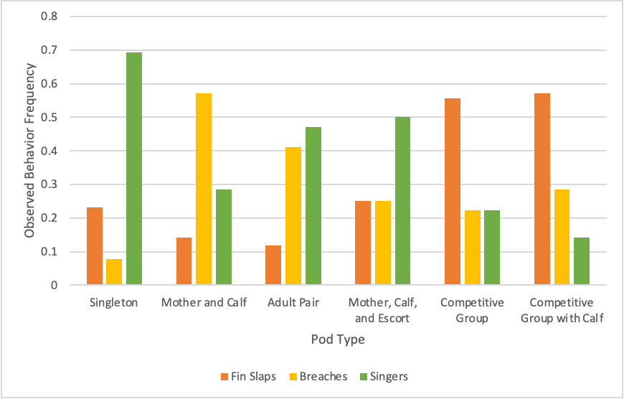
Figure 4. A visual representation of the behaviors, fin slaps, breaches, and singing, most likely to be expressed by each pod type based on the frequency of observed behaviors throughout the winter mating season. Pod types include singleton pods, mother and calf pods, adult pair pods, mother, calf, and escort pods, competitive groups, and competitive group with a calf present. Frequencies calculated from number of observations shown in supplemental materials, Table 2.

Looking at pod type, composition, and behavior through a temporal context throughout the winter breeding season, I was able to see a correlating trend in both behavior and pod size (Fig. 4). The number of whales observed per three hour survey for each observational day increased until observation day 13 (March 17, 2023), and then rapidly decreased (Fig. 5a). The number of whales per pod remained somewhat steady until observation day 12 (March 11, 2023) in which the number of whales per pod hit a peak, then decreased rapidly (Fig. 5b). The number of breaches observed per three-hour survey reached a peak at observation days 2 (January 20, 2023) and between days 11 and 13, then dramatically decreased until the end of the season (Fig. 5c). Fin slap occurrence per number of three-hour surveys peaked at observation day 13 (March 17, 2023), then dramatically decreased (Fig. 5d).
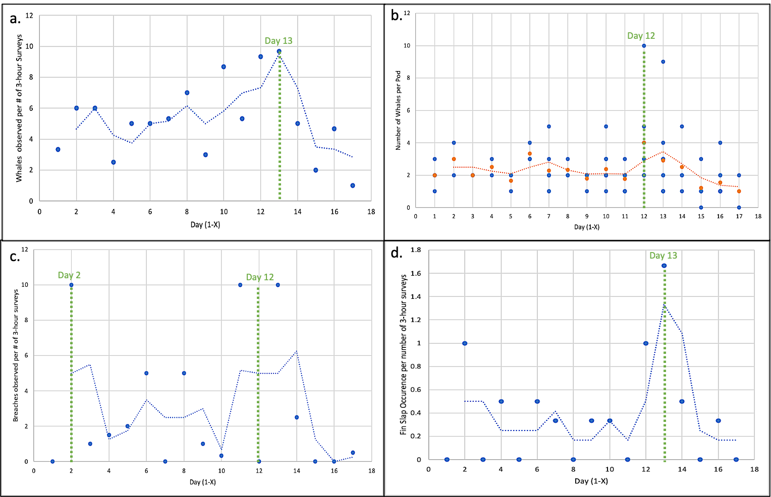

Figure 5 shows the observed number of whales per pod throughout the season (a.), as well as the number of whales (b.), number of breaches (c.), and fin slap occurrences (d.) per three-hour survey for each observation day (Days 1-X). There were 17 observation days, beginning January 13 (Day 1) and ending April 1, 2023 (Day 17). The blue line represents the moving average in plot a, c, and d. The peak day for each plot is shown in green. Plot b shows the average number of whales per pod in orange, with a moving average trendline.

Discussion
The data indicated that behaviors are not expressed equally by different pod types. Looking at differences in behavior expression, fin-slaps are a more aggressive, competitive behavior, which may be why they were most often expressed with competitive groups (Kavanagh et al. 2017). However, a calf present may alter the aggression shown by the whales, which is why competitive groups displayed fin slapping less when a calf was present (Kavanagh et al. 2017). Breaching can be used by whales for multiple different reasons, one being to signal to other pods in the area (Kavanagh et al. 2017). Breaching is more likely not for close-range within-group communication, while fin-slaps are more likely used for close range, within-group communication (Kavanagh et al. 2017). This may be the reason for adult pairs being the pod type with the highest occurrence of breaching, rather than competitive groups which showed the highest frequency for fin slaps. Research has shown that male whales are the ones that audibly sing for the purpose of long-range communication and locating other pods (Herman et al. 2013, Kavanagh et al. 2017). This may indicate why adult pairs and singletons showed the highest occurrence of singing, as they may be trying to locate other pods.
While I did not record the sex of the whales observed in the field, the data can provide some insight as to the proportion of singletons that were males, based on the occurrence of singing. As shown in tables 2 and 3 in supplemental materials, there were 24 total observed occurrences of singing, 9 of those were singletons, 8 of those were adult pairs. Of the total number of singletons (22), the hydrophone was used for 13 singleton pods. Of those, 9 were observed to be singing. Because we know male whales are the ones that sing (Herman et al. 2013), this indicates that majority of the singletons observed were males. This aligns with previous research indicating that females without calves are more attractive due to higher reproductive potential, as most females without calves were seen in larger groups of at least two adults. This also aligns with research indicating that often times singers are alone (Herman et al 2013). When looking at pod composition, it is difficult to tell based on visuals alone. While generally adult pairs and pods with more than one adult are more likely to be male and female combined, male-only pods are not uncommon especially during migration (Corkeron & Brown 1995). It could also be a possibility that a proportion of the adult pairs recorded singing in the study were male only pairs, giving insight as to why adult pairs had the highest frequency of singing.
There are many variables to consider when looking at whale behavior that my research did not encompass. For example, the depth of the water in which the pod is in can impact the behaviors observed (Kavanagh et al. 2017). For example, mother and calves tend to reside in shallower water to possibly avoid predators or harassment from other whales (Kavanagh et al. 2017, Frankel et al. 2022). This may influence the behaviors expressed by mother and calf pods in shallower waters, or could impact the behaviors that competitive males express when following females with calves closer to shore. Females with calves have also been known to avoid other whales to prevent injury to their calves, which may impact the movement of a consisting of a mother, calf, and multiple escorts (Tyack & Whitehead 1983, Kavanaugh et al. 2017). If the mother and calf are moving quickly as avoidance, the males following must move quickly to keep up, which could possibly impact the behaviors expressed.
Another variable that may impact behaviors expressed is environmental conditions. For example, according to prior research whales are more likely to fin-slap with increased wind speeds (Kavanaugh et al. 2017). This could be because fin-slaps provide a more direct means of communication in a more noisy environment. However, the peak day for observed fin-slap occurrence in my data was March 17 (Fig. 5), and conditions on that day were sunny, light winds, and swell of only 2-3 feet, meaning wind speed may not have played a large role in fin slap occurrence. Another important aspect to consider is the effect of one behavior on the frequency of occurrence of other behaviors. For example, other studies have shown that the probability of observing fin slaps decreases with increasing number of singers in the area (Kavanaugh et al. 2017).
Considering temporal trends for whales observed, whales per pod, fin-slapping occurrence, and breaching frequency, there was a clear trend with peaks correlating around days 12-14 (mid-March) with dramatic decreases following. This indicates that the number of available females most likely decreased around and after this peak point in the season, resulting in increased competition and larger pods with more adult males. This would explain the peak in fin-slapping, a competitive form of communication within larger pods. My research aligned with data shown in previous studies, indicating there are generally more whales per pod towards the end of the season when female availability decreases (Tyack and Whitehead 1983). As there are fewer available females, pod sizes decrease rapidly towards the end of the season. Another factor that may play a role in the increase of competitive behavior may be the movement of whales between the Hawaiian Islands. In previous studies, research has shown that males are more likely to move between islands whereas females are more likely to reside in one island throughout the season (Cerchio et al. 1998). Towards the end of the season, whales from other islands (possibly Maui where most whales reside during mating season) may travel to O‘ahu as one final effort to secure a mate.
Whales feed in nutrient rich high latitude waters. Whale prey abundance, including zooplankton and forage fish, is dependent on the physical environment and the factors that influence it. Physical forcing, e.g., Elkman transport, storms, Pacific Decadal Oscillation, upwelling, etc., can cause an increase in the nutrient concentration in the water, resulting in changes in zooplankton and forage fish abundance. Thus, climate change which causes changes and abnormalities in the physical processes that influence whale prey abundance can also influence the population distribution, as well as migration (Frankel et al. 2022). This indicates that as climate change continues to alter physical forcing and cause more frequent heat waves and abnormal climate patterns, humpback whale migration may be impacted. The number of whales present in each breeding ground can be altered by poor feeding conditions in the high latitude feeding areas. Frankel et al. (2022) found that lower overall whale number in breeding grounds is lower 18 months after an unfavorable feeding season. These changes in whale migration may impact mating behavior, reflected by pod composition. Understanding how mating behavior changes may give insights to the future of humpback whale population changes under the influence of climate change and depleted food sources in high latitudes.
Looking towards the future, this data compiled with data from more mating seasons to compare with external factors (e.g., food abundance) which would give insight to the impacts of climate change on whale mating and migration. Mass migrations of mammals worldwide are under threat due to climate change, anthropogenic factors, and unsustainable hunting (Harris et al. 2009). To aid in conservation of mass migrants such as humpback whales, preserving freedom of movement in response to seasonal extremes, as well as ecological drivers and habitat needs is of upmost importance (Harris et al. 2009).
This research has given a little more insight to the social structure of humpback whales in the mating season off leeward O‘ahu. The behavioral and temporal trends found in this research in general align with previous studies and with the predictions for this study.

Supplemental Materials
Raw data submitted in a separate file including data calculations and graph analysis.
Equipment List
- Canon DSLR Camera with 70-300 mm Zoom lens (from Wild Side Specialty Tours)
- Canon DSLR Camera with 100-400 mm Zoom lens (from Wild Side Specialty Tours)
- Hydrophone (from Wild Side Specialty Tours)
- Garmin (navigational chart built in to captain’s helm) (from Wild Side Specialty Tours)
- Binoculars (Captain Flow’s personal)

Table 2 (First Chi-Square Test) shows the expected and observed frequency of behavioral events per each pod type. Pod types include 1A (single adult), MC (mother and calf), 2A (two adults), MCE (mother, calf, and escort), CG (competitive group), and CGwC (competitive group with a calf). Expected frequency follows the null hypothesis that there is no variance in the frequency of behavioral events across different pod types. The p-value is the significance of variation from the null after running a chi-square test.
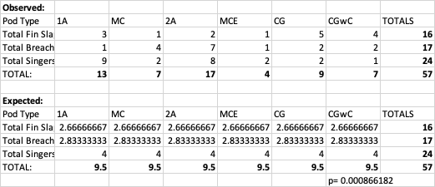

Table 3 (Second Chi-Square Test) shows the expected and observed frequency of each pod type expressing a behavior (fin slaps, breaches, or singing). Pod types include 1A (single adult), MC (mother and calf), 2A (two adults), MCE (mother, calf, and escort), CG (competitive group), and CGwC (competitive group with a calf). Expected frequency follows the null hypothesis that there is no variance in the expression of different behaviors for each pod type. The p-value is the significance of variation from the null after running a chi-square test.
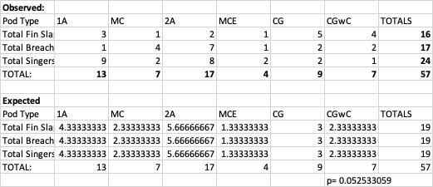

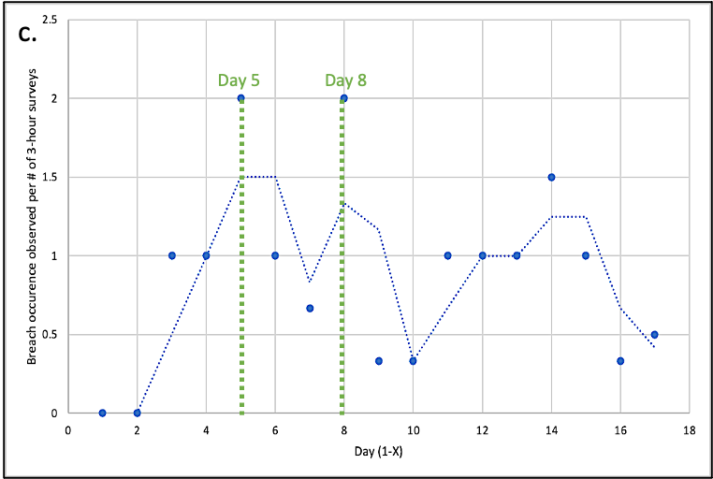
Figure 6. Shows the occurrence (number of pods that expressed breaching) per survey over observation days. There were 17 observation days, beginning January 13 (Day 1) and ending April 1, 2023 (Day 17). The blue line represents the moving. The peak days (days with the highest occurrence of breaching) is shown in green, on observation days 5 and 8.

Acknowledgements
There were many individuals involved in the collection of data for this study. I would like to thank Captains Florence Dixon, Michael Palabay, and Matt Milyak. I would also like to thank photographers Conner Humann and Caden Sweaney. I would like to thank Wild Side Specialty tours and Tori Cullins for the allowing me to collect data onboard the Alaka’i, and for allowing the use of their photos, as well as helpful information and guidance. I would like to thank my classmates for their edits and recommendations in the writing of this report. I would like to thank Hawai’i Pacific University College of Natural Sciences, and finally I would like to thank Dr. Chelsie Counsell for the support and guidance throughout the research process.

Works Cited
Avila, I. C., Dormann, C. F., García, C., Payán, L. F., & Zorrilla, M. X. (2020). Humpback whales extend their stay in a breeding ground in the Tropical Eastern Pacific. ICES Journal of Marine Science, 77(1), 109–118. https://doi.org/10.1093/icesjms/fsz251

Barlow, J., Calambokidis, J., Falcone, E.A., Baker, C.S., Burdin, A.M., Clapham, P.J., Ford, J.K.B., Gabriele, C.M., LeDuc, R., Mattila, D.K., Quinn, T.J., II, Rojas-Bracho, L., Straley, J.M., Taylor, B.L., Urbán R., J., Wade, P., Weller, D., Witteveen, B.H. and Yamaguchi, M. (2011). Humpback whale abundance in the North Pacific estimated by photographic capture-recapture with bias correction from simulation studies. Marine Mammal Science, 27: 793-818. https://doi.org/10.1111/j.1748-7692.2010.00444.x

Brower, L. & Malcolm, S. (1991). Animal migrations: endangered phenomena. American Zoologist, 31(1), 265–276. https://doi.org/10.1093/icb/31.1.265

Cartwright, R., & Sullivan, M. (2009). Associations with multiple male groups increase the energy expenditure of humpback whale (Megaptera novaeangliae) female and calf pairs on the breeding grounds, Behaviour, 146(11), 1573-1600. doi: https://doi.org/10.1163/156853909X458377

Cerchio, S., Gabriele, C., Norris, T., & Herman, L. (1998). Movements of humpback whales between Kauai and Hawaii:implications for population structure and abundance estimation in the Hawaiian Islands. Marine Ecology Progress Series, 175, 13–22. https://doi.org/10.3354/meps175013

Corkeron, P., & Brown, M. (1995). Pod characteristics of migrating humpback whales (Megaptera novaeangliae) off the East Australian coast. Behaviour, 132(3-4), 163-179. doi: https://doi.org/10.1163/156853995X00676

Craig, A. S., Herman, L. M., & Pack, A. A. (2002). Male mate choice and male-male competition coexist in the humpback whale (Megaptera novaeangliae). Canadian Journal of Zoology, 80(4), 745–755. https://doi.org/10.1139/z02-050

Frankel, A. S., Gabriele, C. M., Yin, S., & Rickards, S. H. (2022). Humpback whale abundance in Hawai‘i: Temporal trends and response to climatic drivers. Marine Mammal Science, 38( 1), 118– 138. https://doi.org/10.1111/mms.12856

Franklin, T., Franklin, W., Brooks, L., Harrison, P., Baverstock, P., & Clapham, P. (2011). Seasonal changes in pod characteristics of eastern Australian humpback whales. Marine Mammal Science, 27(3), 152. https://doi.org/10.1111/j.1748-7692.2010.00430.x

Harris, G., Thirgood, S., Hopcraft, J., Cromsight, J., & Berger, J. (2009). Global decline in aggregated migrations of large terrestrial mammals. Endangered Species Research, 7, 55–76. https://doi.org/10.3354/esr00173

Herman, L. M., Pack, A. A., Rose, K., Craig, A., Herman, E. Y. K., Hakala, S., & Milette, A. (2011). Resightings of humpback whales in Hawaiian waters over spans of 10-32 years: Site fidelity, sex ratios, calving rates, female demographics, and the dynamics of social and behavioral roles of individuals. Marine Mammal Science, 27(4), 736–768. https://doi.org/10.1111/j.1748-7692.2010.00441.x

Herman, L. M., Pack, A. A., Spitz, S. S., Herman, E. Y. K., Rose, K., Hakala, S., & Deakos, M. H. (2013). Humpback whale song: who sings? Behavioral Ecology and Sociobiology, 67(10), 1653–1663.

Kavanagh, A.S., Owen, K., Williamson, M.J., Blomberg, S.P., Noad, M.J., Goldizen, A.W., Kniest, E., Cato, D.H. and Dunlop, R.A. (2017). Evidence for the functions of surface-active behaviors in humpback whales (Megaptera novaeangliae). Marine Mammal Science, 33, 313-334. https://doi.org/10.1111/mms.12374

Kettemer, L. E., Rikardsen, A. H., Biuw, M., Broms, F., Mul, E., & Blanchet, M.-A. (2022). Round-trip migration and energy budget of a breeding female humpback whale in the Northeast Atlantic. PLOS ONE, 17(5), e0268355. https://doi.org/10.1371/journal.pone.0268355
Prendergast, B. (2005). Internalization of seasonal time. Hormones and Behavior, 48(5), 503–511. https://doi.org/10.1016/j.yhbeh.2005.05.013

Tyack, P., & Whitehead, H. (1983). Male competition in large groups of wintering humpback whales. Behaviour, 83(1-2), 132-154. doi: https://doi.org/10.1163/156853982X00067

