Final Thesis

Target detection in coral sand by bottlenose dolphins (Tursiops truncatus)

Sofia Dahl

LiTH-IFM-Ex--SE

Contents

1 Abstract 1
2 Introduction 1

2.1 The sonar system 2
2.2 Sonar detection capability 3
2.3 “Crater-feeding” 4
2.4 Objective 5
3 Materials and methods 6
3.1 Study site and subjects 6
3.2 ELVIS – The EchoLocation Visualization and Interface System 6
3.3 Sonar target 8
3.4 The sessions 8
3.4.1 Training procedure 8
3.4.2 Recordings 11
3.5 Analysis 12
4 Results 13
4.1 Target detection 13
4.2 ELVIS sonar data 14
5 Discussion 16
5.1 Conclusion 19
5.2 Future research 20
6 Acknowledgements 20
7 References 21

1 Abstract

With their sophisticated sonar bottlenose dolphins can detect targets buried in sediment. In the waters off the Bahamas, wild dolphins have been observed detecting and extracting fish buried in coral sand, a behaviour called crater-feeding. Although echolocation is heard during this behaviour, its role is poorly understood.
Three bottlenose dolphins at Dolphin Encounters, Bahamas, were trained to find and retrieve targets, successively buried until invisible in coral sand.
A hydrophone matrix mounted on a fabric was placed under a thin layer of sand in a test arena on the bottom of a sea pen and custom made computer software visualized the dolphins’ sonar beam pattern on the PC screen.
Throughout the training the dolphins seemed to rely much on cues from their trainers to find the targets. The typical search strategy was to echolocate in a scattered way in the direction where the trainer pointed. If not detecting the target within a few seconds, they continued this unsystematic echolocation until they did find it; often only after the trainer again pointed in the direction of the targets.
During seven days with 2-4 sessions per day they reached the point where they found buried targets after watching the trainer bury and pointing towards them, sometimes repeatedly, and sometimes by ploughing through the sand with their rostrum. This suggests that sonar was not the primary cue to detect the targets. Further trials are needed to explore the possibility that learning may enable them to extract useful information from their sonar echoes.

Keywords: crater-feeding, hydrophone matrix, search strategy, sonar beam pattern

2 Introduction

The bottlenose dolphin (Tursiops truncatus) is a highly adaptable species (both sensoryily, ecologically and to conditions in human care). They have a broad geographical range and inhabit a variety of habitats (Wood & Evans 1980), including rivers and estuaries, coastal waters, and open oceans (Ridgeway 1990). Their behaviour is closely tied to local ecology and feeding is the activity most often associated with particular temporal and ecological conditions (Shane 1980). This is demonstrated by the variety of preys and foraging strategies observed in this species (Shane 1980, Herzing 2004).
Although bottlenose dolphins have very good vision (Wood & Evans 1980, Ridgeway 1990), they possess a highly sophisticated and adaptive passive and active sonar system (Au 1980) allowing them to effectively navigate, avoid obstacles and predators, and detect prey in waters so murky, turbid or dark that vision is severely limited (Herman 1980, Au 1993). It is known that dolphins use their passive (Wood & Evans 1980, Dubrowskiy 1990, Herzing 2004) and active sonar in certain foraging strategies in the detection and capture of pelagic prey (Au 1993) but still little is known about the use of echolocation in the wild (Herzing & dos Santos 2004).
Dolphins in the Bahamas have been observed to detect and dig out fish buried in coral sand while producing audible sonar sounds (Rossbach & Herzing 1997, Herzing 2004). The use of echolocation in this behaviour is poorly understood, e.g. if the dolphins extract useful information from the echoes from the buried fish or if they use other cues to detect the fish. However, bottlenose dolphins are able to detect and classify targets buried over 45cm into mud (Nachtigall et al. 2000) and dolphins have also been trained to detect buried mines for military use (in bottom material unknown) (Moore 1997 in Masters & Harley 2004, Martin et al. 2005); so it seems to be a potential skill of this species. Bottlenose dolphins show a good adaptability to conditions in captivity (Wood & Evans 1980) and studies on captive dolphins have proven very useful to shed some light on the behaviour of their wild relatives.

2.1 The sonar system
The echolocation sounds of bottlenose dolphins are trains of short (50-80 μs) broadband (few kHz to 150 kHz) clicks produced in an adaptive manner (Au 1993). The source level ranges to over 230 dB re 1μPa at 1m (Au 1993). When these clicks hit objects/surfaces in the water they reflect back as echoes which are received and processed by the dolphin. From these echoes they can resolve distances and size, shape and material of targets (Au, 1993).
The sounds are produced pneumatically within the nasal complex located below the blowhole, and superior to the skull. Pressurized air is metered through the nasal passages past structures called the phonic lips, setting them and associated tissue complexes into vibration (Amundin & Andersen 1983, Ridgway et al. 1980, Cranford et al. 1996). These tissue-borne vibrations are transferred in a forward direction to the fatty forehead tissue called the melon (Cranford et al. 1996). It consists of a unique fatty material with low acoustic absorbance and with structured sound speeds (Varanasi & Malins cited in Au 1993) enabling it to act as an acoustic lens and project the sounds into the water in a highly directional beam (Au 1993). The beam is projected at an elevation angle of 5 degrees above the animal’s head in the vertical plane and has a -3 dB beam width of approximately 10 degrees in both the vertical and horizontal plane (Au et al. 1986, Au 1993). In order to scan a wider area than that covered by the narrow, directional sonar beam, the dolphin makes sideward, scanning movements with the head (Norris & Harvey 1974).
The sounds are received through a relatively thin region on each side of the mandible, the so-called pan bone region or the “acoustic window” (Norris 1968 cited in Au 1993, McCormick 1970, Brill et al. 1988). The sound is transduced, via a fat-filled canal (consisting of a similar fatty material as in the melon) inside the pan bone, directly to the auditory bulla which contains the middle and inner ear (Norris 1964 & 1968 cited in Au 1993). The hearing is adapted to the wide frequency range of the clicks and extends to 150 kHz with greatest sensitivity between about 40 and 100 kHz (Johnson 1967 cited in Au 1993). The bottlenose dolphin has sound discrimination capabilities in water equivalent to those of humans in air and is able to detect and classify a weak signal in a noisy environment better than any other vertebrate tested (Au 1993).

2.2 Sonar detection capability
When the click sounds hits an object in the water a percentage of its energy will be reflected back toward the dolphin as echoes. The strength of the echo depends on the acoustic properties of the target. The majority of the reflected sound energy will arise from the target’s surface but a portion of the energy will penetrate and may undergo further scattering within the target contributing to the structure of the echo by creating a series of echo “highlights”. The inter-click-intervals (ICI), when range-locked to a target, are normally 20 to 40 ms longer than the time required for a signal to travel to the target and back again. This delay is called the lag time and represents the time necessary to receive and process the echo, before the next click is emitted. This lag time is omitted when echolocating at very close range (less than 0.4m), when the intervals get far too short for an echo-by-echo processing and the dolphin may be processing several echoes at a time (Au 1993).
Thanks to the dolphins’ very short clicks and advanced hearing they are able to detect very small differences in the arrival times of the echo highlights. They can resolve very small distance differences and discriminate between very similar targets by size, shape, wall thickness and material (Hammer & Au 1980, Au & Pawlowski 1992, Au 1993). Their extraordinarily high source level also gives them a long detection range: a 7.6cm stainless-steel sphere in the water can be detected at a distance greater then 100m (Au & Snyder 1980, Murchison 1980).
Bottlenose dolphins can even detect buried targets. Within the US Navy’s Marine Mammal Program dolphins outperform man-made systems in locating underwater targets, particularly in cluttered environments and even with buried targets (Martin et al. 2005) like mines (Moore 1997 in Masters & Harley 2004). Also, a computer model created by Roitblat et al. (1995) has predicted that dolphins can effectively recognize and discriminate between targets buried in mud. This was later confirmed by an empirical study by Nachtigall et al. (2000).
However, acoustic reflection can be a fairly complex process and recognizing buried targets in the seabed is a great challenge for dolphins. A large portion of the echolocation signals will be reflected from the seabed surface and/or be scattered (Urick 1983). However, it is possible to extract useful information from deeper in the seabed, because sound penetrates through some seabed materials to some depth (Masters & Harley 2004), longer if there is low difference in impedance between water and the sediment, like e.g. in silt, and shorter if the impedance difference is big, e.g. between water and coral sand. The amount of energy reflected back to the dolphin is dependent on a number of factors: the size of the bottom particles, the angle of incidence of the signal (Urick 1983), the source level, frequency composition of the click, the target strength, the acoustic impedance mismatch between the medium and the target, interfering noise and reverberation (Moore & Pawlowski 1990, Au 1993).

2.3 “Crater-feeding”
Apparently bottlenose dolphins can detect fish buried in sand at depth up to at least several tens of centimetres (Roitblat et al. 1995). They have been observed along with Atlantic spotted dolphins, to echolocate while scanning and digging for buried prey in sandy bottoms near Grand Bahamas Island, Bahamas (Rossbach & Herzing 1997). Rossbach & Herzing (1997) termed this foraging strategy “crater-feeding” because a crater was left in the sand after a dolphin had extracted a buried fish. They concluded that “crater-feeding” is an important strategy for some dolphins. The typical feeding pattern of the dolphins was to search over the sand bottom for several seconds with the head moving from side to side and with a head-down orientation. Echolocation clicks were audible in the water and when forward movement stopped, clicks increased in repetition rate, suggesting that some cue was detected. The dolphin then plunged into the sand, continuing to echolocate, and dug out a small fish could sometimes be seen in its mouth. Scanning usually resumed immediately. The fact that the click repetition rate is increased from 200 to 500 Hz as they direct their sound into the sand (Herzing 2004) indicates that sonar is utilized.
However, it is not clear how the fish are detected. The prey species observed in this foraging strategy were conger eels (family Congridae) (Rossbach & Herzing 1997) and gobies (family Gobiidae) (Kathleen Dudzinski, pers. comm.). Other deeply burying fish such as snake eels (family Ophichthidae) and razorfish/wrasses (family Labridae) have been detected and dug out by bottlenose dolphins scanning the coral sand horizontally while echolocating as well (Herzing 2004). These species all lack swim bladder (which would have given them a higher target strength; Love 1978, Foote 1980), but have different acoustic properties than coral sand (fish flesh resembles soft rubber (Love 1978)), and hence should be possible to detect by the sonar. However, maybe the dolphins are not detecting the fish per se, but rather the acoustic representation of the hollow in the sand created by the fish. Or, maybe they do not use any such cues at all, but rely on the small crater-like breathing holes of the buried fish or their faecal piles on the surface of the sand. Another possibility, since many of the fish species normally live above the sand, is that the dolphins see the fish dart down into the sand to hide when its predator approaches (Kathleen Dudzinski, pers. comm.). Since dolphins have good hearing it is also possible that they can detect sounds made by the fish, for example chewing or moving in the sand.

2.4 Objective
The objective of this study was to shed light on the crater-feeding behaviour by investigating if bottlenose dolphins can be trained to detect targets buried in coral sand, using their sonar, and if so, if they used any particular search strategy. It is an explorative study conducted in a semi-natural pool at Dolphin Encounters (DE), Nassau, Bahamas. The target used was designed to allow two hypotheses concerning what cues the dolphins might use to find the buried fish in the wild to be tested: the echo of the fish/target itself and/or the echo of the hollow in the sand created by the fish’s body.

3 Materials and methods

3.1 Study site and subjects
The study was conducted between 2007-01-14 and 2007-01-20 at Dolphin Encounters (DE), Nassau, Bahamas. The facility consists of 6 interconnected semi-natural seawater pools (and additional holding pools). The study area (“Swim #4”; Fig. 1) had a seabed of coral sand and small rocks, the water depth was 4-5m depending on the tide, and the visibility was 4-10m.
Three male dolphins participated in the study; Jake, 30 year old, wild born, Stormy, 15 year old, wild born, rehabilitated after having stranded in September 1991, and Shawn, 10 year old, born in human care.

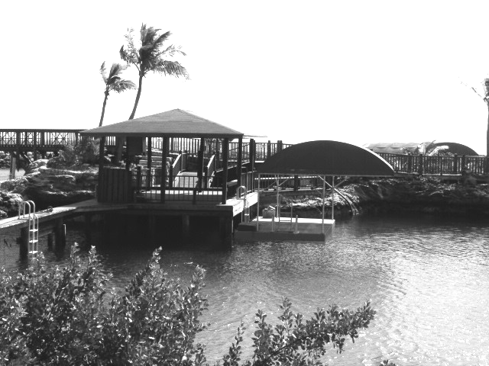
Figure 1. The study area (swim #4). Located in one of the pools at Dolphin Encounters, Nassau, Bahamas.

3.2 ELVIS – The EchoLocation Visualization and Interface System
The ELVIS system is based on an original concept by M. Amundin, which has been implemented at Lund University in cooperation with Kolmården Wild Animal Park (Nilsson 2003) and further developed for this study by Josefin Starkhammar (Starkhammar 2007). It includes 16 hydrophones mounted on a Vira fabric in a 4*4 matrix (1*1 m, 25cm between each hydrophone; Fig. 2a). The hydrophones measure the sound pressure level (SPL) of incoming sounds i.e. the sonar beam of dolphins. The signals are transferred via cables to an amplifier and signal conditioning unit and from there via the parallel port to a desktop computer. Signal processing is performed by custom designed LabVIEW software. This software uses the SPL values to calculate the maximum sound intensity, i.e. the sonar beam axis, which is indicated on the PC screen as a coloured dot. In order to improve the rather coarse resolution given by the 16 hydrophones, the exact location of the maximum sound intensity point is derived through interpolation between the hydrophones in the matrix. Hence it is possible to exactly trace the sonar beam axis of a dolphin exploring the area covered by the hydrophone matrix. The colour of the dot indicates the intensity of the sonar click – from red to white with increasing intensity. The X/Y coordinates for these dots were stored in a log file for each session, allowing a session to be replayed for analysis.
One of the ELVIS matrix hydrophone was connected to a NewLeap ECD-1 click detector, and its output was recorded via the soundcard of the PC on the harddisk.
Each day the matrix was placed on the bottom of the enclosure since it had to be brought up at the end of each day for safety reasons. It was covered with approximately 5cm of dry fine coral sand taken from the beach nearby (Fig. 2). The hydrophones were only covered by ca. 0.5cm of sand. This was because no echolocation sounds were picked up when they were buried deeper. This was probably because air was trapped in the sand when covering the matrix. Air results in severe attenuation of underwater sound. The cables from the hydrophones were covered with rocks and sandbags and attached with cable ties to one of the poles supporting the visitors’ platform were all the equipment was placed. The hydrophone matrix was delineated by a square of grey coloured 20mm PVC tubing with a weight attached in each corner to make it stay in position on the seabed (Fig. 2c).

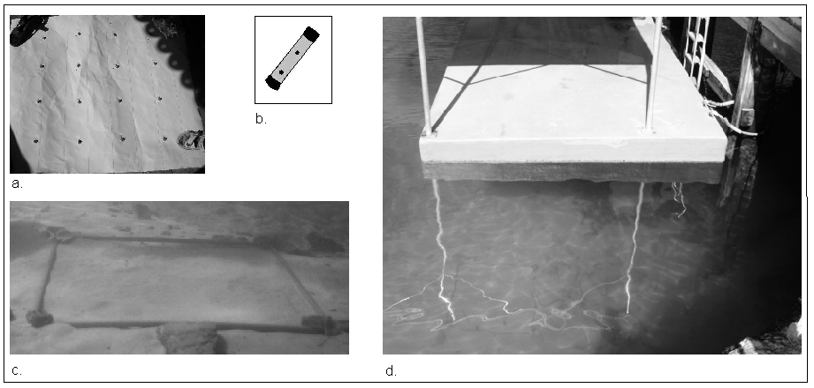

Figure 2. Some of the components used to observe the dolphins sonar beam pattern when searching for partly and completely buried targets in coral sand: a, The ELVIS hydrophone matrix with 16 hydrophones mounted on a fabric in a 4*4 matrix (1*1 m, 25cm between each hydrophone). b, a drawing of the 10cm long target made of grey coloured 20mm PVC tubing, filled with three iron nails. c, the coral sand arena were the hydrophone matrix is placed and covered with ~5cm of coral sand and marked by a square of the same PVC material as the target. d, the arena positioned beneath the floating platform. Wires from the matrix are lying visible on the sand surface and stringed along a pole up through the water to the PC and software that collects sonar data from the hydrophone matrix.

3.3 Sonar targets
Three identical targets were made from the same PVC tubing as used in the arena frame. Each was 10cm long, with small holes, drilled to let out air, filled with three iron nails and closed with self-vulcanizing tape at the ends (Fig. 2b). The iron nails was used to enhance the target strength (TS) since the target strength of PVC is very weak. When buried, the PVC tubes were filled with water, but only with negligible amounts of sand; hence making a hollow in the coral sand.

3.4 The sessions
The dolphins were one at a time progressively trained to retrieve targets on/in the sand. A total of 25 sessions were conducted with one to three dolphins participating each session. On average four sessions were conducted per day between 09:00 and 18:00. Jake participated in all 25 sessions, Stormy in 17 and Shawn in 15 sessions. The number of sessions, the time and duration of the sessions and the number of dolphins participating in each session was restricted by the daily public performances.

3.4.1 Training procedure
The dolphins at DE were not actively trained or encouraged to use their sonar previous to this study. But they were already trained to collect and retrieve objects, both man-made and natural, to the trainers and even visitors. They were also experienced in being trained underwater by a diving trainer. These skills were built upon for this study.
Since the PVC target was new to them, they were first getting accustomed to it. They were taught to hold one of them in their mouth above the water surface and to give it back to the trainer and also taught a cue for the target, i.e. a closed fist.
A session started with the trainer at the surface giving the dolphin a plastic ring on its rostrum, and then sending it down to give it to a scuba gear trainer, who was sitting on the seabed, next to the hydrophone arena. The dolphin stationed itself by pressing its rostrum towards the trainer’s palm. The trainer took the ring from the dolphin’s rostrum and kept it during the session, and indicated that the session was over by putting it back on the dolphin’s rostrum and sending it back to the surface trainer. The surface trainer followed the events using a diving mask, in order to assist the seabed trainer and if necessary correct the dolphin if something went wrong.
The first session started with the target being put into the mouth of the dolphin to indicate to it what it was supposed to pick up. Then the target was placed on top of the sand inside the arena. The dolphin was stationed on the hand and then given the cue for the target (closed fist; Fig. 3) and the cue “pick up and retrieve” (pointing towards the arena and/or target with the forefinger; Fig. 4). When it did so correctly, it was bridged by means of a dog clicker, and given fish from a container on the scuba trainer.
Successively all three targets were introduced, and had all to be picked up before rewarding and then gradually covered by sand. They were placed horizontally, pressed down in the sand, and then additional sand was drawn over them. Eventually the targets were buried in different places in the arena, three at a time for up to three times in a row for each dolphin in a session. In each session the first three targets where placed before the dolphin was sent down to the seabed. If the targets were placed once again it was in the presence of the dolphin. They were buried between 60% and 95 % into the sand, most often with only one black tip visible (90% buried). The trainer chose himself where and how deep the targets were to be buried. They were often placed near but never directly over the hydrophones.
When one of the dolphins, Stormy, for the first time was exposed to a completely buried target, and failed to find it, the training method was changed. Stormy’s behaviour indicated that he maybe did not understand that retrieving partly buried and completely buried targets was the same correct behaviour to be rewarded. To make this clear to the dolphins, a target was now placed, while the dolphin was watching, in the same spot at first on top of the sand and then completely buried.

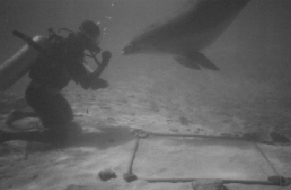
Figure 3. The dolphin is taught a sign for the target, a closed fist. It was shown each time the dolphin was given the cue to find and retrieve a target in the coral sand arena.

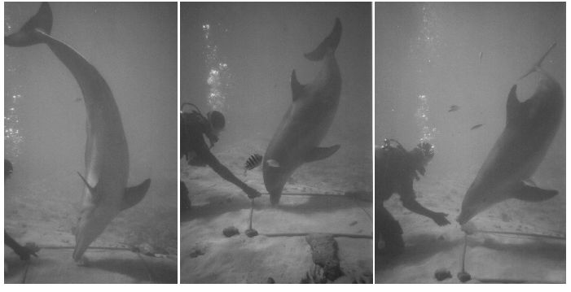
Figure 4. The dolphins were trained to find and retrieve targets successively buried until invisible in a coral sand arena. They retrieved the targets after the trainer gave them a search cue i.e. pointed at the arena and/or the targets.

3.4.2 Recordings
The sessions were observed from the seabed by a scuba observer and from above using a viewing bucket from a floating platform (Fig. 5). During session #1-12 the surface observations were only made by the surface trainer at the surface, who commented continuously on the seabed activity. From session #13, all surface observations were made directly by me. In each session, notes were taken on each step the trainer asked the dolphin to do, and from session #13 on approximately where the targets were placed in the arena, and the time of retrieval of the targets. The oral comments on the activities on the seabed were recorded on to a SONY Dictaphone, which made it possible to later synchronize them with the ELVIS sonar data.
The PhD student operated the PC and the software that collected the sonar data from the hydrophone matrix during the sessions.

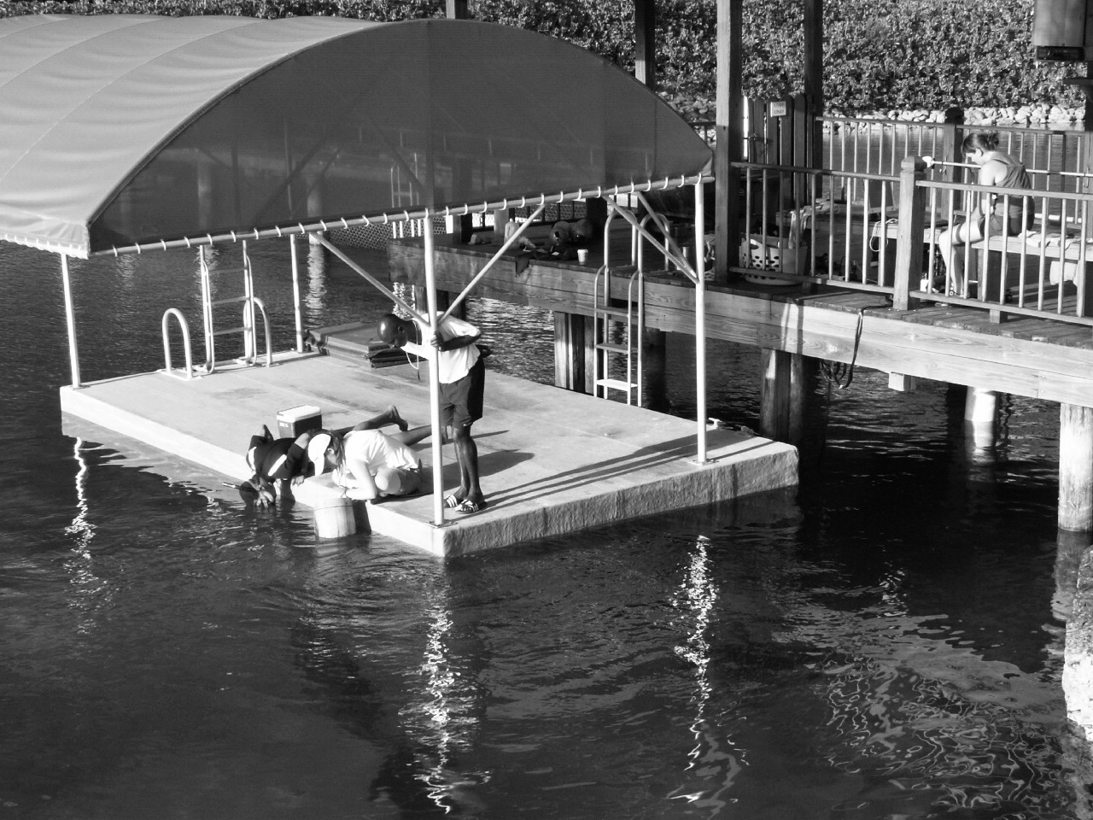
Figure 5. The recordings of the sessions took place on a floating platform where the seabed activities were observed using a viewing bucket. The PhD student operated the PC and software that collected the sonar data from the hydrophone matrix.

3.5 Analysis
The dolphins’ behaviors following the trainers cue to retrieve a target and the timing of the behaviors were received from the Dictaphone.
Twelve of the sessions (session # 13-21, 23-25) had the data needed for analyzing the dolphins’ success of detecting a target and their behavior. The analysis of the duration of the search for the targets was based on 89 retrievals of partly buried targets and 17 retrievals of completely buried targets by Jake. Excel was used to calculate mean and standard deviation of the search time for each dolphin.
To analyze the dolphins’ use of sonar and their possible search strategy, custom made designed National Instruments LabVIEW 8.2 software was used. It made it possible to replay the sonar beam axis trace over the search arena and to compare this with the timing of the behaviors and the position of the targets in the matrix. This software included features like fast forward replay, making it easier to scan through the session in order to find interesting sections. It also had a slow motion replay which made it easier to follow the details in the often fast scanning movements of the dolphins.
Eleven of the sessions (session # 13-21, 23-23) had the data needed for analyzing the search strategy. This analysis was based on 64 of the partly buried targets and 17 of the completely buried targets retrieved by Jake.

4 Results

4.1 Target detection
The dolphins searched the arena with their body oriented almost vertically and with their rostrum close to the seabed (Fig. 4).
For each dolphin it took six to seven sessions until they consistently retrieved partly buried targets. During this learning phase and in the first few sessions, they sometimes tried to pick up the frame made of the same PVC tubing as the target, bite the hydrophones and sometimes they also chose to retrieve a rock (a behaviour included in their trained behavioural repertoire). For the dolphin to retrieve the target in these sessions, the trainers had to point directly at it, often several times and sometimes they had to touch it for the dolphins to understand what to do. In the following sessions the trainer still often pointed directly at the targets, sometimes more then once for the dolphin to pick it up.
The search was sometimes interrupted by the dolphin surfacing for air (sometimes several times during a search for the same target) or when the dolphin did not pay attention or got distracted and swam away for a while. Each time this happened, and the dolphin returned to the trainer, it was given the search cue once again.
Shawn’s search duration for partly buried targets was 1-23s (n=26) with mean=5.5 and SD=5.8, Jake’s was 1-23s (n=27) with mean=6.9 and SD=6.2, and Stormy’s was 1-20s (n=36) with mean=7.8 and SD=6.0.
The dolphins often picked up the target within a few seconds after the trainer pointed towards it or the arena, either when given the cue the first time, after given the cue once again during the search or after the trainer just pointed towards the target during the search. Whether or not the dolphin was near the arena when the targets were being buried did not seem to affect the time it took for it to pick up the targets after been given the search cue.
From session #17 both Shawn and Jake sometimes ploughed in the sand with their rostrum in their attempts to find the targets, if they did not detect it within a few seconds.
In session #19 Stormy did not retrieve the first completely buried target in spite of him searching the arena continuously for approximately 3min. During the search, the trainer pointed towards it repeatedly and it is possible that Stormy scanned over the target a few times with the sonar. Not until the trainer made it somewhat visible, Stormy did retrieve it.
During session #20-21 and #23-24, the dolphins retrieved completely buried targets, which had been placed in their presence and pointed at. Jake’s search duration for completely buried targets was 1-27s (n=17) with mean= 8.5 and SD=7.7. The target was retrieved either within a few seconds or after the dolphin ploughed a short distance in the sand to find it.

4.2 ELVIS sonar data
Echolocation was both audible via the click detector speaker and visible on the computer screen during all sessions analysed.
Echolocation was shown extensively on and around the visible hydrophones and along the edge of the arena during the sessions (Fig. 6 & 7). The echolocation trace along the edge of the arena may indicate that the dolphins followed the PVC frame delineating it, using it as a reference point during the search, but it is also possible that they echolocated outside the arena or, touching the periphery hydrophones with the edge of the sonar beam.
They did not seem to have a special strategy, e.g. where they scanned the arena systematically from one end to the other, covering the whole arena. Rather, the sonar search was somewhat scattered with the click trains interrupted by silent gaps and jumps in the trace displayed on the computer screen (Fig. 6 and 7).
The typical sonar search pattern was as follows (Fig. 6 & 7): The dolphin’s echolocated along a portion of the edge of the arena next to the trainer while given the search cue. In response to the search cue, they started to echolocate in a scattered way towards the target, possibly in the direction the trainer pointed, sometimes following the edge of the arena frame. If they did not detect the partly visible target, by vision and/or sonar, within a few seconds, they continued to echolocate on and between the hydrophones and in the edge of the arena until they did locate and retrieve it. If the trainer pointed towards the target during the search, the dolphin often aimed the sonar in that direction and then picked it up within a few seconds.
When the dolphin picked up a target, the sonar beam axis trace was most often visible over the area where the target was placed. However, sometimes the trace was more over the hydrophones near the target then directly on/over it.
During the time Stormy searched for the completely buried target in session #19, he echolocated intensively in the arena and seemed to quickly pass over the target a few times with the sonar beam (Fig. 8) without detecting it. The time of retrieval of this target once it was made a bit visible is not known exactly, but he seemed to echolocate in the area of the target before/when picking it up.

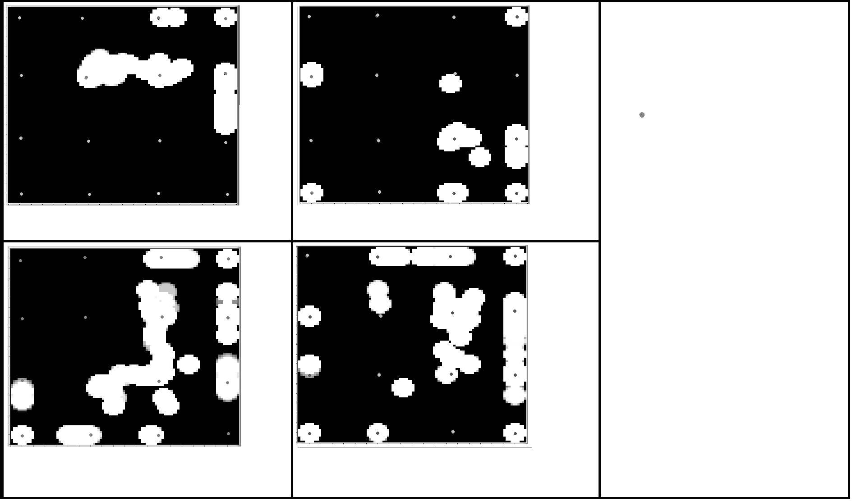
a.
b.

d.
c.
Trainer
Sonar beam
Target area
Hydrophones
Figure 6. Typical search patterns of the dolphins searching for partly/completely buried targets in the coral sand arena. The pattern is somewhat scattered during the search. Echolocation is visible in the area of the target before/when picking it up. a, a 2s long search. b, a 4s long search. c, a 5s long search with the target placed in the edge d, a 9s long search.

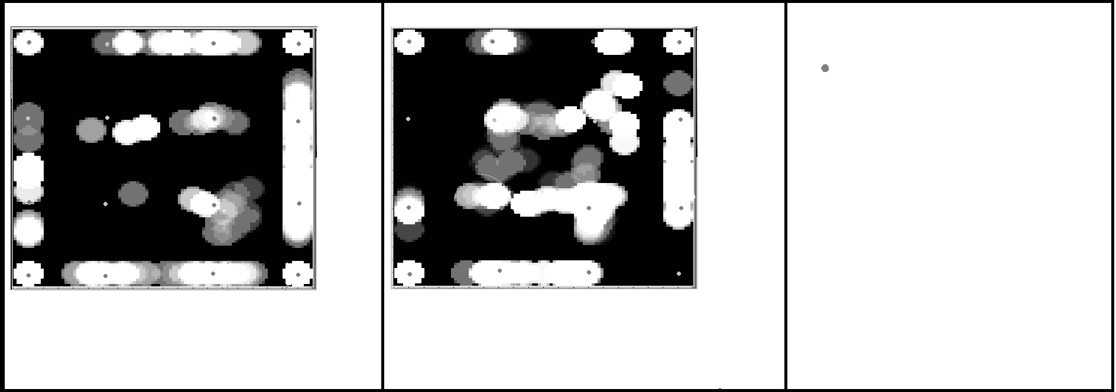
Hydrophones
Target area
Sonar beam
Trainer
a.
b.

Figure 7. Search pattern of the dolphins searching for partly/completely buried targets in the coral sand arena. The dolphins retrieved the targets after been given the search cue a second time during the search. Echolocation is visible in the area of the target before/when picking it up. a, search pattern of a 17s long search where the dolphin did not direct the sonar in the direction of the target after given the search cue. He was once again stationed and given the cue during the search. b, a 23s long search where the dolphin was surfacing for air during the search and was once again given the search cue when back with the trainer at the seabed.


Hydrophones
Target area
Sonar beam
Trainer
Figure 8. Sonar beam pattern of the search for the first target to be completely buried. The dolphin did not retrieve it despite searching for approximately 3 minutes, possible passing over it a few times with the sonar. Once it was made slightly visible it was quickly retrieved. The time of retrieval is not exactly known but the dolphin seemed to echolocate in the area of the target before/when picking it up.

5 Discussion

The results suggest that these dolphins did not use sonar as the primary cue when detecting buried targets. During the training process the dolphins seemed mostly to rely on the trainers’ referential pointing to find the targets.
During the first sessions, the learning phase, the normal confusion occurred when the dolphins were trying to figure out what behaviour was expected of them. The fact that the targets and the frame delineating the arena was made of the same PVC tubing seemed to confuse them at first because they sometimes tried to pick up the whole PVC frame. They also tried to bite the hydrophones which had the same colour as the target endings and was made of plastic with the piezo-ceramic inside. Sometimes they retrieved a pebble instead of the target. The is quite understandable, since this is part of their trained behaviour repertoire, used to give a treat, for example a pebble, to the visitors participating in the close encounter programs (pers comm., Annette Dempsey).
It did not seem as if the dolphins learned to extract information from the sonar echoes from the buried parts of the targets. First of all the partly buried targets were visible at various degrees with at least one of the black tips visible, which contrasted quite well with the light colored sand. Since they have very good vision (Wood & Evans 1980, Ridgeway 1990) it is very likely that the dolphins could see this without using their sonar.
Although the dolphins often did not have to search for long until they retrieved the targets, the search times were quite variable. When a target was retrived within a few seconds it is possible that the dolphin had located the target before given the search cue, by vision and/or sonar and/or that they followed the direction the trainer pointed when giving the search cue. The difference in time could be because the trainers were not always consistent when giving the cue, sometimes pointing over the arena and not directly towards a target. Also, once the dolphin started to search, it kept its rostrum very close to the sand surface and therefore both its vision in front of the rostrum tip and sonar beam coverage may have been limited. If they started a focussed search in the wrong place, it would inevitably take some time to find the target.
During session #17, two of the dolphins started to plough in the sand with their rostrum. This behaviour was then often used in the remaining session where all targets were successfully retrieved. Session #17 did not differ from the previous ones in any obvious way; the targets were not covered more and the matrix had not been moved since the previous session. Why they started to plough in this way is not clear, but it indicates that they had found a method to solve their task, neither relying on vision nor sonar, but on the trainer’s referential pointing and their sense touch on the rostrum tip. The fact that sonar was still used might have been because this behaviour is locked to close inspection of any object (Au, 1993).
The fact that the first target to be completely buried was not detected, despite the dolphin searching for approximately 3min, indicates that he was not able to extract the necessary information from the sonar echoes. The trainer pointed towards it repeatedly and even if the sonar beam axis might not have passed directly over the target, some portion of it did. As soon as it was made a bit visible, it was quickly detected, suggesting that vision was providing the necessary cue for detection. However, the possibility that he just did not understand that retrieving partly buried and completely buried targets was the same behavior to be rewarded cannot be excluded (Annette Dempsey, pers. comm.³). Unfortunately, this situation was never tried again, with neither of the dolphins, so it is difficult to draw any conclusion.
The ELVIS data show a somewhat scattered pattern with extensive echolocation on the hydrophones and along the edge of the arena. The fact that the hydrophones attracted attention is not surprising considering that they were objects new to them, possible giving clear echoes in the otherwise familiar seabed. The dolphins maybe tried to figure out whether they were the target or not. The extensive echolocation on the hydrophones could, however, also be explained by the equipment used. The dolphins searched for the target at a close distance to the matrix and when a hydrophone apparently was pinpointed, it might be because the dolphin was too close to the matrix so that the sonar beam did not ensonify but one hydrophone. This would make the interpolation function fail, and hence not showing the correct position of the beam axis. The same error is possible when the sonar beam trace apparently was following the arena frame – since there were no hydrophones outside the arena, the interpolation could only work in line with the outer hydrophone array. Hence, the true trace outside the outer hydrophone array could not be shown. In order to eliminate this error, a finer hydrophone matrix would be necessary as well as having hydrophones outside the search arena. This is underway.
Maybe the dolphins cannot be trained to detect the targets if vision and/or passive hearing and not sonar provide the primary cue for finding buried preys. It is possible that the crater-feeding dolphins search the seabed with its sonar and when, for example, breathing holes on the surface are discovered by vision and/or sonar, it continues to echolocate to enhance the detection and capture of the fish.
However, there are some factors that need to be considered, that could explain why these dolphins, after only a week of intense training, seemed to fail to find the buried targets by sonar. Searching with sonar into the sand is a challenging task due to the complex reverberation and attenuation in the sand. The amount of energy reflected back from a target to the dolphin depends on the sediment type, the angle of incidence of the signal, the frequency of the signal (Urick 1983) and on the target strength (Roitblat et al. 1995, Nachtigall et al. 2000).
Coral sand seems to have a slightly higher attenuation than other sediments (Fu et al. 2004), although lab measurements on the coral sand attenuation suggest that it is possible for sound with considerably lower source levels (SL) than the dolphin sonar, to penetrate down to at least 10cm (Starkhammar, pers.comm.).
Another important factor is that there was an evident difference in the body posture of these dolphins and the wild dolphins during crater feeding: the body of the latter pointed at an angle to the seabed (Rossbach & Herzing 1997), whereas the former were almost vertical. This would allow the wild dolphins to avoid the strong seabed surface echo that may mask the much weaker echo from the buried fish. In the experiments reported by Nachtigall et al. (2000), where a dolphin detected and discriminated targets in mud, it was positioned vertical to the mud surface. However, the acoustic impedance of mud is closer to water, which would make the surface echo weak compared to that of coral sand. Still, although it was an experienced dolphin, it required a considerable effort to train her to detect the buried targets.
Most important of all is that these dolphins were inexperienced with any sonar seabed exploration. They had never been asked to perform such a task before; instead they had been trained to pick up objects on the surface of the seabed, which is an easy task compared to this. Hence, it is possible that the dolphins just need additional training, and a chance to learn how to tune in and extract the echo coming from the buried target. Dolphins can receive echoes from the sonar emitted by another dolphin and therefore get the same information as the echolocating dolphin (Xitco & Roitblat 1996). It has been observed in the Bahamas that young calves echolocate on small flounders, and follow conspecifics during foraging, suggesting that the learning of echolocation skills begin very early in life. Young calves often position themselves under the adults that scan the seabed, giving them a good opportunity to learn just how to use their sonar in finding buried fish (Herzing 2004).

5.1 Conclusion
This was a first attempt to study if dolphins can be trained to detect targets buried in coral sand using their sonar, and if so, what search strategy they might develop when given this task. All three dolphins participating retrieved the partly buried targets, and after seven days and 25 sessions they reached the point were they found targets buried under 5-10mm of sand. Although using their sonar, they seemed to rely on the referential pointing of the trainer, and in the last sessions they ploughed through the sand with the tip of their rostrum, detecting the target by the sense of touch. However, even though the result suggests that the dolphins did not use sonar as the primary cue to detect the buried targets, it is still possible that they may be able to learn to detect buried targets by sonar. This study was based on a limited number of sessions over a short period of time, and with dolphins new to this task. Further trials with these dolphins will explore the possibility that learning may enable them to extract useful information from their sonar echoes.

5.2 Further research
The research on the dolphins search strategy and the possibility to detect buried targets could be further developed in many ways to shed some light on the use of sonar during crater-feeding. For the possibility of detecting a buried target, other targets should be used, in particular ones with air inside. This would give a very distinct and strong echo, possibly easier for the dolphins to detect than the PVC/nail targets. Other kinds of substrate, such as coral sand with a mixture of silt should also be tested. It is necessary to find out exactly what kind of substrate it is on the sites where crater-feeding occurs. Also, the dolphins should be trained to orient themselves in different vertical angles when searching the seabed in order to avoid the strong sand surface echo.
More detailed studies should be conducted with a new version of ELVIS, which will have 64 hydrophones instead of 16, and the capability of recording the full frequency spectrum of the sonar clicks. Together with continuous video camera recordings of the sessions this would give a much more detailed picture of the echolocation search strategies of the dolphins.

6 Acknowledgements

I wish to thank all the enthusiastic and generous people cooperating to make this study possible. First I wish to thank my supervisor Mats Amundin for his expertise and guidance, and who, along with Josefin Starkhammar, provided technical and material support. The warmest thank to Kathleen Dudzinski who made it possible for us to come and stay in the Bahamas and to the competent people at Dolphin Encounters who opened their facility to us and provided materials and method to guide the dolphins towards the goal of this study. Finally I wish to thank all, including John Anderson and Christer Blomqvist, for a wonderful stay in the Bahamas. Thank you!

7 References

Amundin M & Andersen SH (1983) Bony nares air pressure and nasal plug muscle activity during click production in the harbour porpoise, Phocoena phocoena, and the bottlenosed dolphin, Tursiops truncatus. J. Exp. Biol. 165, 275-282.

Au WWL (1980) Echolocation signals of the Atlantic bottlenose dolphin (Tursiops truncates) in open water. pp 251-282 in Busnel RG & Fish JF (eds) Animal Sonar Systems. Plenum Press, New York.

Au WWL (1993) The Sonar of Dolphins. Springer Verlag, New York.

Au WWL & Pawloski DA (1992) Cylinder wall thickness discrimination by an echolocating dolphin. Journal of Comparative Physiology A 172, 41-47.

Au WWL & Snyder KJ (1980) Long-range detection in open waters by an echolocating Atlantic Bottlenose dolphin (Tursiops truncates). J. Acoust. Soc. Am. 68 (4), 1077-1084.

Au WWL, Moore PWB & Pawlowski DA (1986) Echolocation transmitting beam of the Atlantic bottlenose dolphin. J. Acoust. Soc. Am. 80 (2), 688-691.

Brill RL, Sevenich ML, Sullivan TJ, Sustman JD & Witt RE (1988) Behavioral evidence for hearing through the lower jaw by an echolocating dolphin (Tursiops truncatus). Marine mammal science 4, 223-230.

Dubrowskiy NA (1990) On the two auditory sub-systems in dolphins. pp 233-254 in Thomas J & Kastelein R (eds) Sensory Abilities of Cetaceans: Laboratory and Field Evidence. Plenum Press, New York.

Fu SS et al (2004) Acoustic properties of coral sands, Waikiki, Hawaii. J. Acoust. Soc. Am. 115 (5), 2013-2020.

Hammer CE & Au WWL (1980) Porpoise echo-recognition: An analysis of controlling target characteristics. J. Acoust. Soc. Am. 68 (5), 1285-1293.

Herman LM (1980) Cetacean Behavior: Mechanisms and Functions. John Wiley & Sons, Inc., USA.

Herzing D (2004) Social and nonsocial uses of echolocation in free-ranging Stenella frontalis and Tursiops truncatus. pp 404-410 in: Thomas JA, Moss CF & Vater M (eds) Echolocation in bats and dolphins. The University of Chicago Press, Chicago & London.

Herzing D & dos Santos ME (2004) Functional Aspects of Echolocation in Dolphins. Pp 386-392 in Thomas JA et al. Echolocation in bats and dolphins. The University of Chicago Press, Chicago, 2004.

Love RH (1978) Resonant acoustic scattering by swimbladder-bearing fish. J. Acoust. Soc. Am. 64 (2), 571-580.

Martin SW, Philips M, Bauer EJ, Moore PW & Houser DS (2005) Instrumenting free-swimming dolphins echolocating in open water. J. Acoust. Soc. Am. 117 (4) Pt. 1, 2301-2307.

Masters WM & Harley HE (2004) Performance and cognition in echolocating mammals. pp 249-259 in: Thomas JA, Moss CF & Vater M (eds) Echolocation in bats and dolphins. The University of Chicago Press, Chicago & London.

McCormick JG et al. (1970) Sound conduction in the dolphin ear. J. Acoust. Soc. Am. 48 (6), 1418-1428.

Moore, PWB & Pawloski, DA (1990) Investigations on the control of echolocation pulses. pp 305–316 in: Thomas J & Kastelein R (eds) Sensory Abilities of Cetaceans: Laboratory and Field Evidence. Plenum Press, New York

Murchison AE (1980) Detection range and range resolution of echolocating bottlenose porpoise. pp 43-70 in Busnel RG & Fish JF (eds) Animal Sonar Systems. Plenum Press, New York.

Nachtigall PE, Au WWL, Roitblat HL & Pawloski JL (2000) Dolphin bisonar: A model for biomimetic sonars. pp 115-121 in Proceedings of the First International Symposium on Aqua Bio-Mechanisms.

Nilsson M (2003) Echolocation Visualisation Interface System – ELVIS. Undergraduate thesis in Elektrisk mätteknik, Institutionen för Elektrisk Mätteknik, Lunds Tekniska Högskola

Norris KS & Harvey GW (1974) Sound transmission in the porpoise head. J. Acoust. Soc. Am. 56, 659-664.

Ridgway SH (1990) The central nervous system of the bottlenose dolphin. pp 69-97 in: Leatherwood S & Reeves R (eds) The bottlenose dolphin. Academic Press, Inc., San Diego.

Roitblat HL et al. (1995) Sonar recognition of targets embedded in sediment. Neural Networks 8, 1263-1273.

Rossbach K & Herzing D (1997) Underwater observations of benthic-feeding bottlenose dolphins (Tursiops truncatus) near Grand Bahamas Island, Bahamas. Marine Mammal Science 13(3), 498-504.

Shane SH (1980) Behavior and Ecology of the Bottlenose Dolphin at Sanibel Island, Florida. pp 245-265 in Leatherwood S & Reeves RR (eds) The bottlenose dolphin. Academic Press, Inc, San Diego, CA.

Starkhammar J, Amundin M, Olsén H, Ahlmqvist M, Lindström K & Persson HW (2007): Acoustic Touch Screen for Dolphins - First application of ELVIS, an Echo-Location Visualization and Interface System. In: Proceedings from the 4th International Conference on Bio-Acoustics, Loughborough University, UK, April 10-12, 2007

Wood FG & Evans WE (1980) Adaptiveness and ecology of echolocation in toothed whales. Pp381-426 in Busnel RG & Fish JF (eds) Animal Sonar Systems. Plenum Press, New York.

Urick RJ (1983) Principles of underwater sound. McGraw-Hill Publishing Company. New York.

Xitco MJ & Roitblat HL (1996) Object recognition through eavesdropping: Passive echolocation in bottlenose dolphins. Animal Learning & Behaviour 24 (4), 355-365.

Kathleen M. Dudzinski, Ph.D. Director, Dolphin Communication Project & Education Scientist-in-Residence, Mystic Aquarium & Institute for Exploration; Adjunct Faculty at University of So. Mississippi, University of Rhode Island, and Alaska Pacific University.
Not all retrievals of targets during the analyzed sessions could be included. Poor visibility, stirred up sand, bubbles from the seabed trainer, and how the dolphins positioned themselves over the arena made it sometimes difficult to observe all seabed activities and the exact position of the placed targets.
Anette Dempsey, Dolphin Encounters, Nassau, The Bahamas
Josefin Starkhammar, Ph.D. student, Lunds Universitet.

